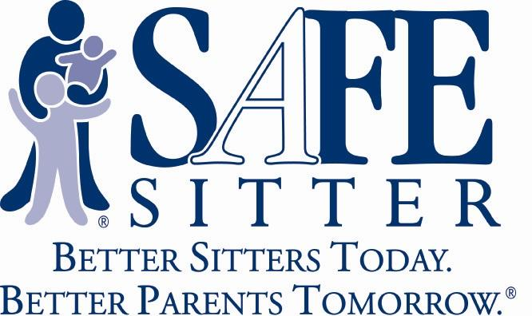
Do you feel comfortable leaving your young teen home alone? Is your teen ready to start watching their younger siblings? Does your teen want to start earning money babysitting?
Register for our upcoming Safe Sitter® class to learn the safety skills he/she needs for themselves and the children they are watching. The cost is $50 which includes: the official Safe Sitter handbook and completion card; child care essentials; choking rescue; CPR training; how to start a babysitting business; and so much more!
You only need to complete one class to receive your completion card!
Register for a class and pay with a credit card online at: www.northstaryouth.org Programs/Safe Sitter Training

REGISTER TODAY- Space is limited to the first 8 students! Registration is closed the Monday prior to class, if there are not enough students signed up by that Monday, the training will be cancelled. So, don’t delay, register today!
- Saturday, August 27, 2016 9:00am-4:30pm ($50)
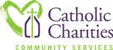
Classes will be held at 434 W. Gurley St. in Prescott, in the Catholic Charities large conference room.
For more information contact:
Kasey Shaver at kshaver@cc-az.org or
928-708-7206

